UNIVERSITY OF MALAWI

College of Medicine

Assessing the Seroprevalence of Measles Antibodies in Malawi
By

Chawanang N Khuwi

MSc-Epidemiology

(MEp 201287654321)

A Dissertation Submitted in Partial Fulfilment of the Requirements of the Master of Public Health Degree

30th June 2026

Certificate of Approval

The Dissertation of Chawanangwa N Khuwi is approved by the Dissertation Examination Committee

Prof XX (Chairman, Post Graduate Committee)

Dr Michael Udedi (Supervisor)

Dr Z Phiri (Internal Examiner)

Dr G Chapotera (Head of Department)

Declaration

I Chawanangwa N Khuwi hereby declare that this dissertation is my original work and has not been presented for any other awards at the University of Malawi or any other University.

Name of Candidate Chawanangwa N Khuwi

Signature

Date 15th December 2017

Acknowledgements
I wish to thank Dr Email Nsima my academic Supervisor, Dr Nathan Sadza my Service Advocate and Prof Vaganov for their inputs during the preparation and writing of this dissertation. I also thank Mr Stata for his statistical support. I am also very grateful to all Department of Public Health Staff as well as my colleagues in the MEp program for their support. My acknowledge-ments would be incomplete without the mention of my wife Trish and my sons Obnoxious and Velocity who have always been by my side.

Abstract

Introduction: Measles remains a major public health problem despite the availability of an effective vaccine. In Malawi, continued outbreaks suggest persistent susceptibility and gaps in control efforts.
Objectives: To determine measles IgM positivity among suspected cases in Malawi, identify associated factors, and describe its distribution across districts.

Methods: A retrospective cross-sectional analytical study was conducted using secondary measles surveillance and laboratory data collected between April 2023 and December 2024. Suspected cases with complete records and IgM results were included. Descriptive statistics, bivariate analysis, and multivariate logistic regression were used.

Results: A total of 1,191 suspected cases were analysed. Overall, 70.1% were IgM positive (95% CI: 67.4–72.6), indicating substantial recent measles transmission. Cases increased in late 2024 and peaked in November. Male sex was associated with higher odds of IgM positivity (aOR = 2.17, 95% CI: 1.19–4.00, p = 0.012). Compared with the Southern Region, odds were lower in the Northern Region (aOR = 0.06, 95% CI: 0.01–0.19, p < 0.001) and Central Region (aOR = 0.31, 95% CI: 0.14–0.64, p = 0.002), showing geographic variation in burden.

Conclusions: Measles remained an active public health problem in Malawi. Male sex and geographic location were important correlates of IgM positivity, supporting stronger surveillance and geographically targeted control efforts.
Table of Contents
Certificate of Approval iii
Declaration iv
Acknowledgements v
Abstract vi
List of Tables x
List of figures x
Chapter 1 Introduction and Objectives of the Study 1
1.1 Background 1
1.2 Statement of the Problem 3
1.3 Literature Review 4
1.4 Objectives 6
1.4.1 Broad Objective 6
1.4.2 Specific Objectives 6
1.5 Conceptual Framework 6
Chapter 2 Methods 8
2.1 Type of research study 8
2.2 Study Place 8
2.3 Study population 8
2.4 Study period 9
2.5 Sample size 10
2.6 Data Extraction 10
2.7 Inclusion criteria 11
2.8 Exclusion criteria 11
2.9 Data management and analysis 11
Chapter 3 results 13
3.1 Introduction 13
3.2 Sociodemographic Characteristics of the Study Population 13
3.3 Overall Seroprevalence of Measles IgM Antibodies 14
3.4 Factors Associated with Measles IgM Positivity 16
3.5 Distribution of Measles Seroprevalence by District 19
3.6 Summary of Results 22
Chapter 4 Discussion 23
4.1 Introduction 23
4.2 Overall measles IgM positivity 23
4.3 Sex differences in measles IgM positivity 25
4.4 Age pattern and vulnerability among infants younger than nine months 26
4.5 Regional and district variation in measles positivity 28
4.6 Strengths and limitations 30
4.7 Public health implications 31
4.8 Summary of discussion 31
Chapter 5 Conclusions and Recommendations 33
5.1 Conclusion 33
5.2 Recommendations 33
5.3 Summary 35
References 36
Appendices 39
7.1 Data extraction form 39
7.2 Ethical approval 39

List of Tables
Table 1: Sociodemographic Characteristics of Suspected Measles Cases, Malawi, April 2023–December 2024 85
Table 2: Bivariate Analysis of Factors Associated with Measles IgM Positivity, Malawi, April 2023–December 2024 89
Table 3: Multivariate Logistic Regression of Factors Associated with Measles IgM Positivity, Malawi, April 2023–December 2024 (N = 1,191) 90
Table 4: Measles IgM Seroprevalence by District, Malawi, April 2023–December 2024, Grouped by Region 91

List of figures
Figure 1: Study Ghant Chart 82
Figure 2: Measles IgM Seroprevalence Among Suspected Cases, Malawi, April 2023 to December 2024 (N = 1,191) 87
Figure 3: Epidemic Curve of Measles Cases by Month of Onset, Malawi, April 2023 to December 2024 88
Figure 4: Choropleth Map of Measles IgM Seroprevalence by District, Malawi, April 2023 to December 2024 (N = 1,191) 94

Abbreviation | Full Term
CHSU | Community Health Sciences Unit
COMREC | College of Medicine Research and Ethics Committee
EPI | Expanded Programme on Immunization
HIV | Human Immunodeficiency Virus
IgG | Immunoglobulin G
IRB | Institutional Review Board
KCH | Kamuzu Central Hospital
KUHeS | Kamuzu University of Health Sciences
LMICs | Low- and Middle-Income Countries
MoH | Ministry of Health
NSO | National Statistical Office
WHO | World Health Organization

Chapter 1 Introduction and Objectives of the Study

Background
Measles is a highly contagious viral disease caused by the measles virus, a member of the genus Morbillivirus within the family Paramyxoviridae. The disease remains one of the leading causes of vaccine-preventable morbidity and mortality worldwide, particularly among children under five years of age in low- and middle-income countries (LMICs). Despite the availability of a safe, effective, and inexpensive vaccine for more than five decades, measles continues to pose a major public health challenge globally (1).

Transmission occurs primarily through respiratory droplets and airborne spread, making measles one of the most infectious diseases known to humans. Clinical manifestations include fever, cough, coryza, conjunctivitis, and a characteristic maculopapular rash. Severe complications include pneumonia, encephalitis, blindness, malnutrition, and death, especially among under five children, immunocompromised individuals and malnourished children (1).

Global measles control efforts have achieved remarkable progress since the introduction of routine childhood immunization. Between 2000 and 2022, measles vaccination prevented an estimated 57 million deaths worldwide. However, disruptions in immunization services, vaccine hesitancy, population mobility, and weaknesses in health systems have contributed to recurring outbreaks in many countries. In 2023, approximately 10.3 million measles cases were reported globally, representing an increase from previous years and highlighting persistent immunity gaps (2).

The African Region continues to experience a substantially high burden of measles. WHO estimates indicate that measles incidence increased from 69.2 cases per million population in 2017 to 81.9 cases per million population in 2021. Several countries in sub-Saharan Africa have reported large outbreaks despite achieving relatively high administrative vaccination coverage, suggesting that reported vaccine uptake may not accurately reflect population immunity (3).

Serological surveys provide an important means of assessing immunity within populations. Unlike administrative vaccination records, seroprevalence studies directly measure the presence of protective antibodies and therefore provide a more accurate estimate of population susceptibility. Such studies help identify immunity gaps, assess vaccine effectiveness, evaluate the success of immunization programmes, and guide supplementary immunization activities (4)

Malawi has made substantial progress in expanding immunization coverage through the Expanded Programme on Immunization (EPI). The country introduced routine measles vaccination in 1979 and subsequently adopted a two-dose measles-containing vaccine schedule. Despite these efforts, Malawi continues to experience periodic measles outbreaks, indicating possible gaps in population immunity. Recent outbreaks have been reported in districts including Lilongwe, Mchinji, and Mangochi, raising concerns regarding the effectiveness and sustainability of measles control interventions.

Available evidence on measles immunity in Malawi remains limited. A seroprevalence study conducted in Chiradzulu District reported that 91.9% of participants possessed protective measles antibodies; however, the study was geographically limited and focused primarily on HIV-infected and non-HIV-infected populations attending health facilities (5). Consequently, there remains a lack of nationally representative data on measles antibody prevalence and its associated factors.

This study seeks to address this knowledge gap by determining the seroprevalence of measles antibodies and identifying associated factors using nationally available surveillance and laboratory data collected between 2023 and 2024. Findings from this study will provide critical evidence for strengthening measles elimination efforts in Malawi.

Statement of the Problem
Although measles vaccination coverage in Malawi has remained relatively high over recent years, outbreaks continue to occur across several districts. The occurrence of these outbreaks suggests the presence of susceptible populations despite routine vaccination programme.

Current national surveillance systems primarily rely on vaccination coverage estimates and laboratory-confirmed cases to monitor measles control. However, vaccination coverage does not necessarily equate to population immunity because factors such as vaccine failure, waning immunity, cold chain interruptions, and inaccurate reporting can influence actual protection levels.

Furthermore, there is limited national evidence regarding the seroprevalence of measles antibodies among populations in Malawi. The only published serological study was conducted more than a decade ago in a single district and may not reflect the current national immunity profile. Without current serological evidence, policymakers may be unable to accurately identify immunity gaps or optimize vaccination strategies.

Therefore, there is a need for a national assessment of measles antibody seroprevalence and associated factors to support evidence-based immunization policies and strengthen progress toward measles elimination in Malawi.

Literature Review
Global Burden of Measles
Before widespread vaccination, measles caused an estimated 2.6 million deaths annually worldwide. Following introduction of measles vaccination programmes, substantial reductions in morbidity and mortality were achieved.
However, WHO reported approximately 10.3 million measles cases globally in 2023, representing a resurgence driven by disruptions in routine immunization services and declining vaccine coverage. Children younger than five years remain the most affected group (6).
Recent outbreaks have been reported in Europe, North America, Asia, and Africa despite availability of highly effective vaccines, demonstrating that elimination requires sustained high levels of population immunity.
Measles immunity
Measles immunity may be acquired through:
- Natural infection
- Vaccination
The presence of measles-specific IgG antibodies is considered a reliable marker of immunity

Global Evidence on Measles Seroprevalence
A national survey conducted in Mexico reported an overall seroprevalence of 99.37%, indicating successful maintenance of herd immunity through high vaccination coverage (7).
additionally, 37.6% of adults aged 20–44 years in the United States lacked protective measles antibodies despite documented vaccination histories (8). The findings suggested that vaccine-induced immunity may wane over time. These studies also demonstrate that vaccination coverage alone may not accurately reflect immunity status.

Measles Seroprevalence in Low- and Middle-Income Countries
A systematic review and meta-analysis (9) found that approximately 81% of infants in LMICs possessed maternal measles antibodies at birth. However, protection declined rapidly to approximately 30% by four months and 18% by seven months of age.
This decline creates a period of vulnerability before routine vaccination, increasing the risk of measles transmission among infants.

Another systematic review found a median measles seroprevalence of 84% across LMICs (10). The review highlighted substantial heterogeneity and methodological limitations among studies, emphasizing the need for standardized serological assessments.

Measles Epidemiology in Africa
Despite improvements in immunization programmes, measles remains endemic in many African countries. Measles incidence in Africa increased significantly between 2017 and 2021. Major outbreaks have been reported in the Democratic Republic of Congo, Ethiopia, Nigeria, and several Southern African countries (3).
Challenges contributing to these outbreaks include:
- Inadequate vaccination coverage
- Weak surveillance systems
- Population displacement
- Health system disruptions
- Vaccine stockouts

These factors contribute to accumulation of susceptible individuals and recurrent epidemics.

Objectives

Broad Objective
To determine the seroprevalence of measles antibodies and its associated factors in Malawi

Specific Objectives
- To determine the seroprevalence of measles antibodies in Malawi.
- To identify factors associated with measles antibody seropositivity.
- To describe the distribution of measles seroprevalence by district.

Conceptual Framework
The conceptual framework assumes that measles seropositivity is influenced by the following:
Independent Variables
- Age
- Sex
- District of residence
- Vaccination status i.e time of last vaccination
- Sample condition
- Time specimen collection (time between sample collection and testing)
Dependent Variable
- Measles antibody status (Positive/Negative)
These factors influence the development and persistence of protective measles antibodies, which ultimately determine population immunity.

Chapter 2 Methods

Type of research study
It is a retrospective cross-sectional analytical study, that will use secondary data generated by Expanded Program on Immunization - measles unit in Malawi.
The National Expanded Programme on immunization (EPI) in Malawi is a government entity under the Ministry of Health that coordinates the planning, implementation, and monitoring of immunization services across the country. The EPI headquarters is located at the Public Health Institute of Malawi (formerly known as Community Health Sciences Unit - CHSU) in Lilongwe, Malawi.

Study Place
According to the NSO 2018 projection the total population in 2025 was estimated at 20,734,262 (13). The measles data was generated in all 29 administrative districts namely Chitipa, Karonga, Likoma, Mzimba, Nkhata Bay, Rumphi, Dedza, Dowa, Kasungu, Lilongwe, Mchinji, Nkhotakota, Ntcheu, Ntchisi, Salima, Balaka, Blantyre, Chikwawa, Chiradzulu, Machinga, Mangochi, Mulanje, Mwanza, Neno, Nsanje, Phalombe, Thyolo, and Zomba.

Kamuzu central Hospital laboratory is a National measles testing site, engulfed within serology department. Situated in the central region of Malawi, largest referral hospital for the Central Region and beyond. It receives approximately 70 samples in a month.

Study population
The study population comprised all suspected measles cases reported to the National Expanded Programme on Immunization (EPI) surveillance system whose specimens were submitted to the Kamuzu Central Hospital laboratory for measles IgM testing. A suspected case was defined according to the standard EPI case definition and included individuals presenting with fever and maculopapular rash, irrespective of age, sex, or vaccination status, drawn from across Malawi's administrative districts. Only suspected cases with complete demographic records and a valid IgM test result were eligible for inclusion in the final analysis, consistent with the inclusion and exclusion criteria described above.

Study period
The study covered a 21-month period from April 2023 to December 2024. This period was selected because it captured a sustained phase of measles surveillance and laboratory testing activity at Kamuzu Central Hospital, including a marked rise in suspected and IgM-positive cases beginning in August 2024 and peaking in November 2024. Restricting the analysis to this period ensured that the dataset reflected a complete and consistent surveillance window, rather than fragments of activity from non-contiguous reporting periods. See the study ghant chart (Figure 1)

ACTIVITY | OCT | NOV | DEC | JAN | FEB | MAR | APR | MAY | JUN | JUL
Proposal development, developing data extraction tool
Ethics review, approval and clearance
Data entry and cleaning
Data analysis
Write up
Dissemination

Figure 1: Study Ghant Chart

Sample size
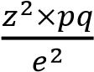
Sample size for the study will be calculated using the formula indicated below (12):
n= where:
n = Sample size,
p= Prevalence of measles in Malawi (2013) = 28%
q= 1-p= 1- 0.28 = 0.72
e= the margin of error i.e. 5% (0.05)
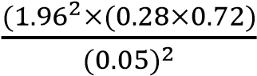
z= 1.96 corresponding at 95% confidence interval
n=
n= 309.7, 10% (31) attrition due to loss of data as a result of incomplete records =310 + 31=341
A minimum of 341 records was therefore deemed necessary to support statistically sound inferences at a 95% confidence level and a 5% margin of error. However, because a sample of this size would not have permitted meaningful generalisation to the national context, the study did not draw a probability sample. Instead, all suspected measles cases meeting the inclusion criteria and reported to the National Expanded Programme on Immunisation (EPI) surveillance system, with specimens submitted to the Kamuzu Central Hospital (KCH) laboratory for IgM testing, were extracted for the study period. This yielded 1,191 eligible cases with complete records and valid IgM results, exceeding the calculated minimum by nearly 3.5 times. Including the full eligible population rather than a calculated subset strengthens the reliability of subgroup analyses by sex, district, and region, and supports more robust multivariate logistic regression modelling.

Data Extraction
This study used secondary data. Given that a calculated sample would have been too small to support meaningful generalisation to the national context, all suspected measles cases meeting the inclusion criteria within the study period were extracted rather than a probability sample. Data were downloaded from the EPI repository database, and case forms were retrieved and matched against the corresponding records in the live database to confirm completeness and accuracy. Each case form contained the accession number, patient demographic details, clinical information (presenting symptoms and underlying conditions), and vaccination history. A structured data extraction form (Appendix 1) was used to capture this information from every eligible case.
Where extraction forms were incomplete, they were cross-checked against the original source case forms to verify accuracy and fill any gaps. Data were transferred from the extraction forms into a Microsoft Excel spreadsheet using a double-entry technique.

Inclusion criteria
All suspected measles cases received and tested by the Kamuzu Central Hospital laboratory between April 2023 and December 2024 were eligible for inclusion.

Exclusion criteria
All samples with incomplete or missing records on variable measles testing result.

Data management and analysis
Data will be stored in a secure, password-protected database or computer with access limited to the responsible personnel.
All data will be checked for duplicates, missing values and inconsistencies and implausible values. The source documents will be used to confirm the values. Data with unexplained outliers will be removed. Clean data will be transferred from Microsoft excel into Stata version 17.0.

Stata version 17.0 will be used to analyze the data. Descriptive statistics will be presented using frequencies and percentages for categorical variables. Chi square will be used to analyze associations between categorical variables. The variable of interest is the Measles sero result (Positive or Negative). Measles outcome will be cross tabulated with other independent variables e.g age, residence, sex. Multivariate regression analysis will be conducted to identify the associated risk factors of measles antibodies and at p-value <0.05. The Odds will be retained in the multiple regression analysis to examine the associations Between the dependent variable and independent variable the while adjusting odd will be presented for potential confounding variables.

Chapter 3 results

Introduction
This chapter presents the results of the analysis of measles surveillance and laboratory data collected in Malawi between April 2023 and December 2024. A total of 1,191 suspected measles cases with complete records were included in the final analysis. The results are organised according to the three specific objectives of the study: the overall seroprevalence of measles IgM antibodies, the factors associated with IgM positivity, and the distribution of seroprevalence by district. Sociodemographic characteristics of the study population are presented first to provide context for the findings that follow.

Sociodemographic Characteristics of the Study Population
Table 1 presents the sociodemographic characteristics of the 1,191 suspected measles cases included in the analysis.
Table 1: Sociodemographic Characteristics of Suspected Measles Cases, Malawi, April 2023–December 2024
Characteristic | n | %
Sex
Female | 447 | 44%
Male | 559 | 56%
Age group
<9 months | 131 | 52%
9–23 months | 12 | 4.8%
2–4 years | 35 | 14%
5–17 years | 63 | 25%
18+ years | 10 | 4.0%
Region
Northern | 115 | 11%
Central | 548 | 50%
Southern | 427 | 39%
Note. N = 1,191. Age group percentages are calculated from cases with complete age data (n = 251). Regional percentages are calculated from the full dataset.

Male cases (56%, n = 559) outnumbered female cases (44%, n = 447). Among cases with complete age data (n = 251), more than half (52%, n = 131) occurred in children younger than nine months, the age group that falls below the routine measles vaccination schedule. Cases from the Central region accounted for half of the sample (50%, n = 548), followed by the Southern region (39%, n = 427) and the Northern region (11%, n = 115).

Overall Seroprevalence of Measles IgM Antibodies
The first objective of the study was to determine the overall seroprevalence of measles IgM antibodies among suspected cases. Figure 2 presents the proportion of suspected cases that tested positive and negative for measles IgM antibodies.
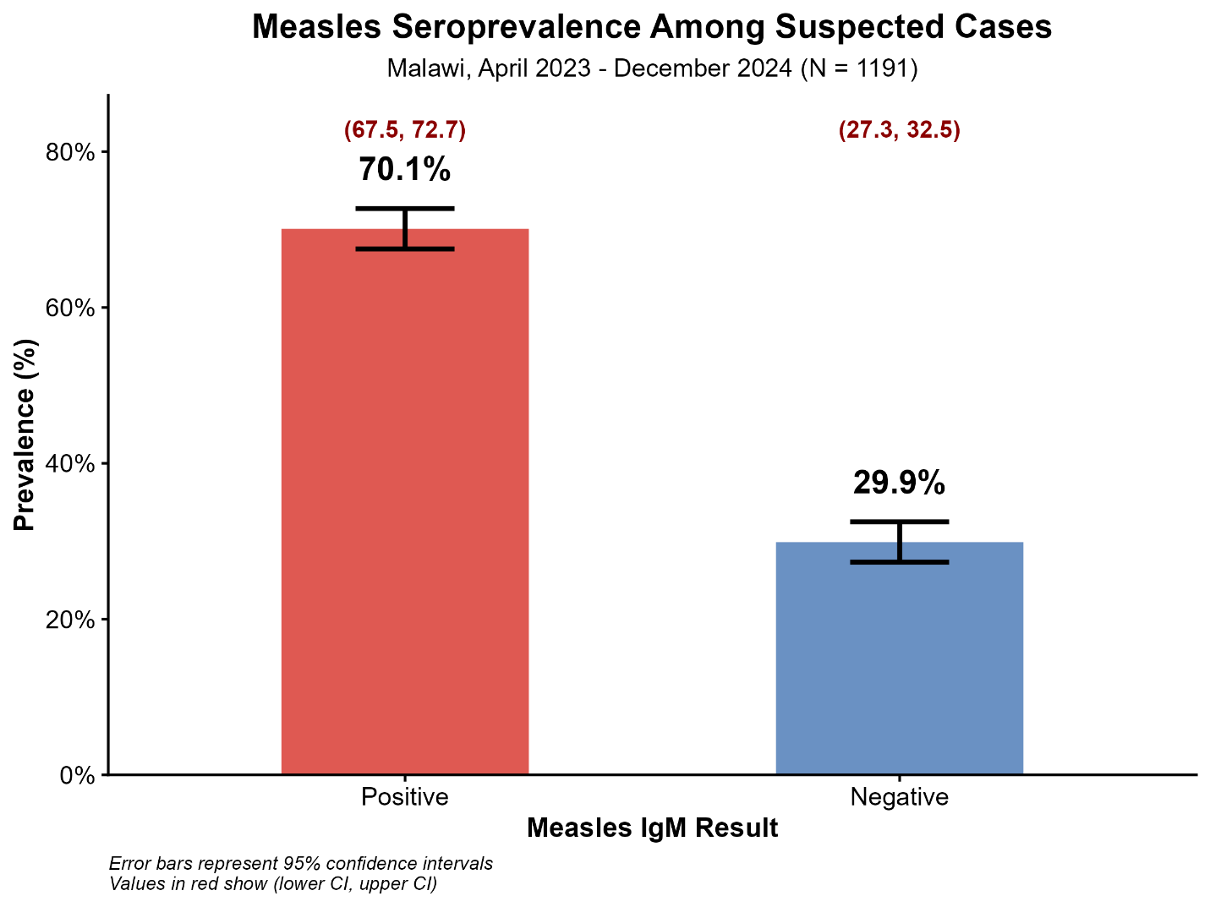
Figure 2: Measles IgM Seroprevalence Among Suspected Cases, Malawi, April 2023 to December 2024 (N = 1,191)
Of the 1,191 suspected cases tested, the majority (70.1%, n = 835, 95% CI: 67.4–72.6) were IgM positive, while the remaining 29.9% (n = 356, 95% CI: 27.3–32.5) tested negative.
Figure 3 presents the monthly distribution of suspected cases tested and IgM-positive cases across the study period.
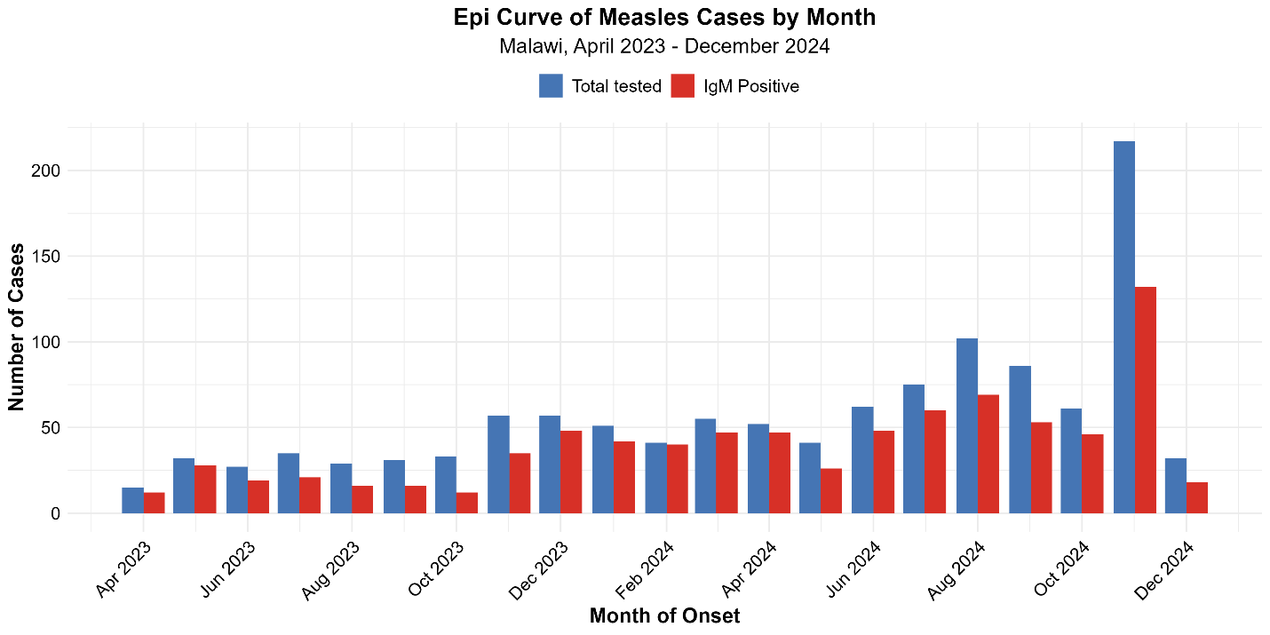

Figure 3: Epidemic Curve of Measles Cases by Month of Onset, Malawi, April 2023 to December 2024
Monthly testing volumes and IgM-positive counts remained relatively low and stable through most of 2023 and the first half of 2024, with positive cases ranging between roughly 12 and 48 per month. A marked rise began around August 2024, and testing and positivity both peaked in November 2024, when 216 cases were tested and 132 were confirmed IgM positive, the highest monthly totals recorded across the entire 21-month period. Case numbers fell sharply in December 2024, the final month of the study period.

Factors Associated with Measles IgM Positivity
The second objective of the study was to identify factors associated with measles IgM positivity. Bivariate analysis using Pearson’s chi-squared and Fisher’s exact tests was first conducted to assess the association between sex, age group, region, and IgM result. Table 2 presents the bivariate analysis.
Table 2: Bivariate Analysis of Factors Associated with Measles IgM Positivity, Malawi, April 2023–December 2024
 | Negative (n = 356) |  | Positive (n = 835)
Characteristic | N | % | N | % | P
Sex |  |  |  |  | 0.002
Female | 160 | 52% | 287 | 41%
Male | 150 | 48% | 409 | 59%
Age group |  |  |  |  | 0.132
<9 months | 54 | 58% | 77 | 49%
9–23 months | 3 | 3.2% | 9 | 5.7%
2–4 years | 8 | 8.6% | 27 | 17%
5–17 years | 22 | 24% | 41 | 26%
18+ years | 6 | 6.5% | 4 | 2.5%
Region |  |  |  |  | <0.001
Northern | 36 | 11% | 79 | 10%
Central | 210 | 63% | 338 | 45%
Southern | 88 | 26% | 339 | 45%
Note. N = 1,191 (356 negative, 835 positive). p-values derived from Pearson’s chi-squared test; Fisher’s exact test was applied where expected cell counts were less than five.

Sex was significantly associated with IgM result (p = .002). Among IgM-positive cases, well over half were male (59%, n = 409), compared to under half of negative cases (48%, n = 150). Age group was not significantly associated with IgM result (p = .132). Region showed the strongest association with IgM result of all the variables tested (p < .001). Southern region accounted for nearly half of all IgM-positive cases (45%, n = 339), almost double its share of negative cases (26%, n = 88), while Northern region contributed a similar proportion to both positive (10%, n = 79) and negative (11%, n = 36) cases.
Variables associated with IgM positivity at bivariate level, together with the other factors specified in the conceptual framework, were entered into a multivariate logistic regression model. Table 3 presents the adjusted odds ratios.

Table 3: Multivariate Logistic Regression of Factors Associated with Measles IgM Positivity, Malawi, April 2023–December 2024 (N = 1,191)
Characteristic | aOR | 95% CI | P
Male (vs. female) | 2.17 | [1.19, 4.00] | 0.012*
18+ years (vs. 2–4 years) | 0.66 | [0.14, 3.20] | 0.602
5–17 years (vs. 2–4 years) | 1.36 | [0.66, 2.87] | 0.407
9–23 months (vs. 2–4 years) | 2.18 | [0.49, 12.14] | 0.328
Northern region (vs. Southern) | 0.06 | [0.01, 0.19] | < 0.001***
Central region (vs. Southern) | 0.31 | [0.14, 0.64] | 0.002**
Note. aOR = adjusted odds ratio; CI = confidence interval. Reference groups: female; age 2–4 years; Southern region. * p < .05. ** p < .01. *** p < .001.

After adjusting for age group and region, male sex remained significantly associated with IgM positivity, with males just over twice as likely as females to test positive (aOR = 2.17, 95% CI: 1.19–4.00, p = .012). None of the age group comparisons reached statistical significance in the adjusted model (all p > .05). Region remained the strongest predictor of IgM positivity. Cases from the Northern region had markedly lower odds of testing positive than cases from the Southern region, with the odds reduced by roughly 94% (aOR = 0.06, 95% CI: 0.01–0.19, p < .001). Cases from the Central region also had significantly lower odds of positivity than the Southern region, though the reduction was less pronounced (aOR = 0.31, 95% CI: 0.14–0.64, p = .002).

Distribution of Measles Seroprevalence by District
The third objective of the study was to describe the distribution of measles seroprevalence across districts. Table 4 presents seroprevalence by district, grouped by region, and Figure 4.3 presents the same data as a choropleth map of Malawi.
Table 4: Measles IgM Seroprevalence by District, Malawi, April 2023–December 2024, Grouped by Region
District | n Tested | n Positive | Seroprevalence [95% CI]
Northern
Chitipa | 6 | 6 | 100.0% [61.0, 100.0]
Likoma | 1 | 1 | 100.0% [5.1, 100.0]ᵃ
Rumphi | 19 | 16 | 84.2% [62.4, 94.5]
Mzimba | 58 | 45 | 77.6% [65.3, 86.4]
Nkhatabay | 2 | 1 | 50.0% [2.6, 97.4]ᵃ
Karonga | 29 | 10 | 34.5% [19.9, 52.7]
Total: Northern | 115 | 79 | 68.7% [59.5, 76.6]
Central
Ntchisi | 14 | 13 | 92.9% [68.5, 99.6]
Dowa | 13 | 12 | 92.3% [66.7, 99.6]
Kasungu | 22 | 19 | 86.4% [66.7, 95.3]
Ntcheu | 19 | 15 | 78.9% [56.7, 91.5]
Mchinji | 77 | 48 | 62.3% [51.2, 72.3]
Lilongwe | 332 | 200 | 60.2% [54.9, 65.4]
Nkhotakota | 33 | 17 | 51.5% [35.2, 67.5]
Dedza | 28 | 13 | 46.4% [29.5, 64.2]
Salima | 10 | 1 | 10.0% [0.5, 40.4]
Total: Central | 548 | 338 | 61.7% [57.5, 65.7]
Southern
Chikwawa | 2 | 2 | 100.0% [34.2, 100.0]ᵃ
Mulanje | 5 | 5 | 100.0% [56.6, 100.0]
Nsanje | 3 | 3 | 100.0% [43.9, 100.0]ᵃ
Phalombe | 4 | 4 | 100.0% [51.0, 100.0]ᵃ
Thyolo | 38 | 37 | 97.4% [86.5, 99.9]
Zomba | 23 | 21 | 91.3% [73.2, 97.6]
Chiradzulu | 18 | 16 | 88.9% [67.2, 96.9]
Neno | 29 | 25 | 86.2% [69.4, 94.5]
Blantyre | 201 | 168 | 83.6% [77.8, 88.1]
Balaka | 25 | 18 | 72.0% [52.4, 85.7]
Machinga | 17 | 11 | 64.7% [41.3, 82.7]
Mwanza | 8 | 4 | 50.0% [21.5, 78.5]
Mangochi | 54 | 25 | 46.3% [33.7, 59.4]
Total: Southern | 427 | 339 | 79.4% [75.3, 83.0]
Grand Total | 1,191 | 835 | 70.1% [67.4, 72.6]
Note. Grand total N = 1,191. CI = confidence interval. ᵃ Districts with fewer than 5 samples

Seroprevalence varied considerably across the 28 districts with available data, ranging from 10.0% in Salima (n = 1 of 10 tested) to 100.0% in six districts, namely Chitipa, Likoma, Mulanje, Chikwawa, Nsanje, and Phalombe, each of which tested fewer than seven cases. At regional level, the Southern region recorded the highest seroprevalence (79.4%, 95% CI: 75.3–83.0), followed by the Northern region (68.7%, 95% CI: 59.5–76.6), while the Central region, despite contributing the largest number of tested cases (n = 548), recorded the lowest regional seroprevalence (61.7%, 95% CI: 57.5–65.7). Within the Central region, Salima stood out as a marked outlier, recording the lowest district-level seroprevalence in the entire dataset despite neighbouring districts such as Ntchisi (92.9%) and Dowa (92.3%) recording among the highest.
Figure 4 presents the geographic pattern of seroprevalence across all districts.

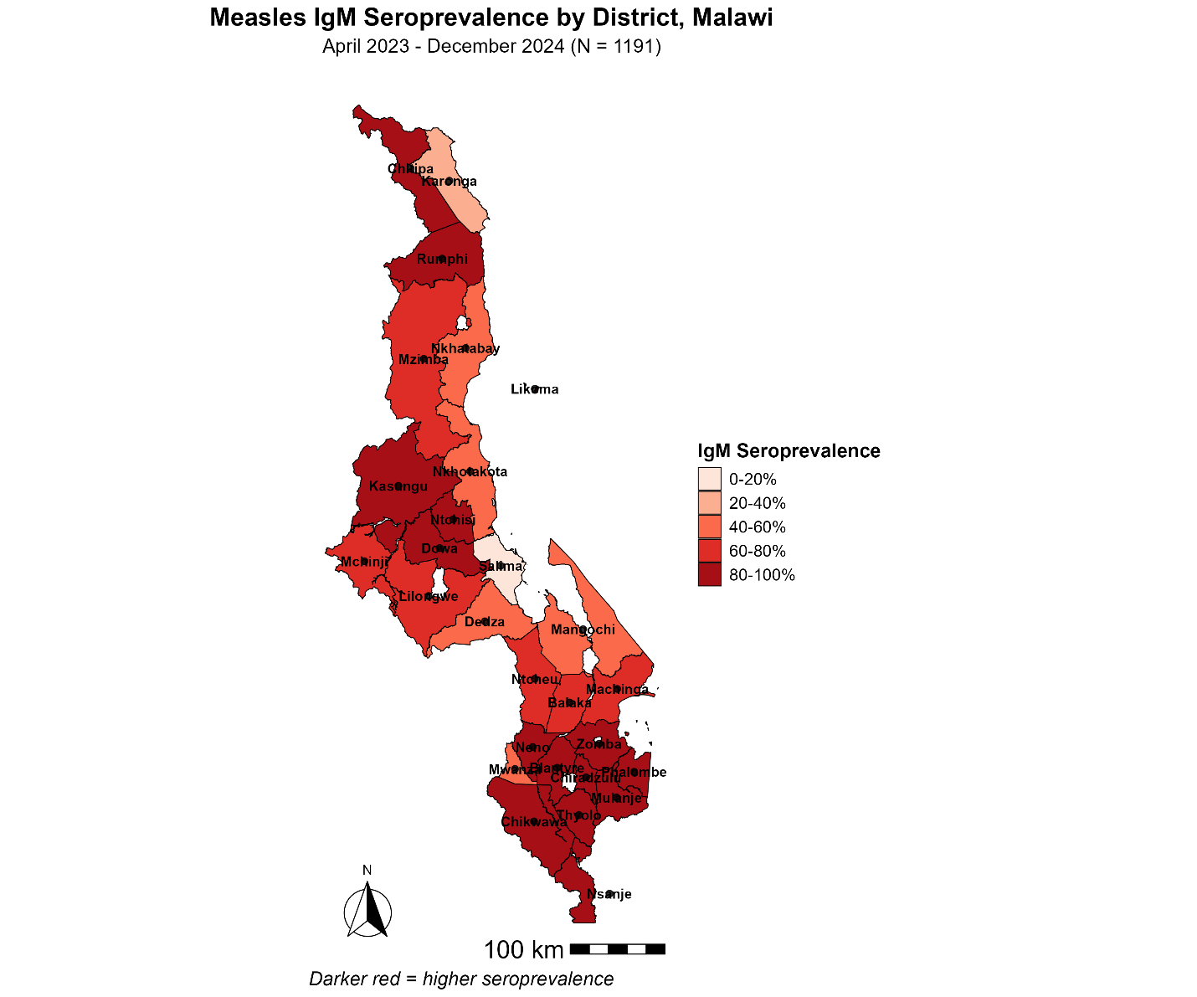
Figure 4: Choropleth Map of Measles IgM Seroprevalence by District, Malawi, April 2023 to December 2024 (N = 1,191)
High seroprevalence (60 to 100%) was concentrated across most of the Southern region and the western districts of the Central region, while pockets of lower seroprevalence (0 to 40%) were visible in Karonga in the far north and in Salima in the Central region.

Summary of Results
Overall, 70.1% (n = 835) of suspected measles cases tested IgM positive between April 2023 and December 2024, with a marked rise in both testing volume and positive cases from August 2024 that peaked in November 2024. Male sex and region of residence were significantly associated with IgM positivity in both bivariate and multivariate analysis, while age group showed no significant association at either level. Seroprevalence varied widely by district, with the Southern region recording the highest regional seroprevalence and the Central region, despite testing the largest number of cases, recording the lowest.

Chapter 4 Discussion

Introduction
This study assessed measles IgM positivity among suspected cases in Malawi between April 2023 and December 2024. The main findings were a high overall IgM positivity proportion, a clear rise in cases during late 2024, a significant association between male sex and positivity, no adjusted age association despite many cases occurring in infants younger than nine months, and marked regional and district variation. These findings are discussed below in relation to the conceptual framework and recent literature published between 2020 and 2026.

Overall measles IgM positivity
The overall IgM positivity of 70.1% suggests substantial measles transmission during the study period. In a dataset of suspected cases, such a high proportion means that many of the clinically suspected cases were true recent measles infections rather than other febrile rash illnesses. The rise from August 2024 and the peak in November 2024 further suggest outbreak expansion rather than isolated sporadic transmission. Within the conceptual framework, this supports the view that measles antibody outcome was shaped by real epidemiologic conditions, not by chance alone.

This finding is consistent with recent regional and global literature showing renewed measles transmission where immunity gaps persist. In the WHO African Region, measles incidence increased between 2017 and 2021, and no country had achieved verified elimination by the end of that period (11). Continued transmission in 2022 and 2023 was linked to stagnant routine coverage, weak second-dose uptake, and incomplete surveillance performance (12). At global level, estimated measles cases rose to 10.3 million in 2023 and the number of countries with large or disruptive outbreaks also increased (3). The present finding therefore complements current evidence that measles remains a persistent public health threat in settings where susceptible individuals continue to accumulate.

The result also suggests that routine vaccination coverage figures alone may not fully reflect effective protection. Recent work has shown that outbreaks often expose immunity gaps that are hidden by national averages (13,14). In that sense, the high IgM positivity in this study is an indirect signal that susceptibility remained high enough in some populations to sustain transmission. Although this study did not measure IgG seroprotection, it still points to the practical consequence of incomplete population protection: continued outbreak activity.

From the conceptual framework perspective, this finding supports the central assumption that measles antibody outcome is influenced by factors operating at both individual and system level. Even though the framework listed age, sex, district, vaccination history, sample condition, and testing interval, the overall high positivity first establishes that the outcome itself reflected a setting with active recent transmission. In other words, the study outcome was meaningful enough to allow the other explanatory variables in the framework to be interpreted against a real outbreak background rather than a low-transmission setting.

In comparison with literature, the present finding is more complementary than contradictory. The exact percentage should not be expected to match every other study because case definitions, laboratory pathways, and surveillance quality differ across settings (12,15). Still, the direction is the same across recent studies: where coverage gaps, surveillance weaknesses, and susceptible clusters persist, measles continues to re-emerge (3,11). That makes the Malawi finding both credible and important.

Sex differences in measles IgM positivity
Male sex remained significantly associated with IgM positivity after adjustment, with males showing higher odds of testing positive than females. This indicates that sex was not merely a descriptive variable in the sample. In terms of the conceptual framework, the finding supports sex as a relevant factor associated with measles antibody outcome in this dataset.

This result is broadly consistent with recent literature, although the available evidence is more limited than for age or geography. A pooled analysis across seven countries found consistently higher measles incidence in males at younger ages, with male-to-female incidence ratios above 1.0 in infancy and childhood (16). The direction of the current finding is therefore plausible. However, the stronger magnitude observed here may reflect local outbreak conditions, differences in exposure, or differences in care-seeking and testing patterns rather than biology alone. Because this study was based on suspected cases in surveillance data, it cannot distinguish clearly between these explanations.

The implication is that sex should not be treated only as a background characteristic in measles surveillance analysis. It may reflect underlying differences in exposure or case detection that deserve closer attention during outbreaks. At the same time, the result should be interpreted cautiously, since the literature does not yet establish a single clear mechanism that would explain a markedly higher positivity among males in Malawi.

In relation to the conceptual framework, this result gives direct support to sex as one of the proposed determinants of measles antibody outcome. Unlike some of the other variables in the framework, sex remained significant after adjustment, which means it retained explanatory value even when considered together with age and region. That strengthens the argument that the distribution of measles IgM positivity in this dataset was not random, but patterned by identifiable characteristics of the suspected cases.

In comparison with literature, the finding is broadly in the same direction as recent evidence showing somewhat higher measles incidence among males in younger age groups (16). However, the current study shows a stronger association than most pooled estimates reported elsewhere. That may indicate local epidemiologic conditions in Malawi, but it may also reflect the nature of the surveillance sample. The current result therefore complements existing literature, while also suggesting that sex-specific patterns in measles positivity may deserve more attention in African surveillance studies.

Age pattern and vulnerability among infants younger than nine months
Age group was not significantly associated with IgM positivity in the adjusted model, but the descriptive findings remain important. Among cases with complete age data, more than half occurred in infants younger than nine months. This is a notable pattern because children in this age group are generally below the routine age for measles vaccination and rely mainly on maternally derived antibodies for early protection. In relation to the conceptual framework, age therefore remains important even though the adjusted association was not statistically significant.

This descriptive pattern agrees with recent evidence on early infant susceptibility. In Malawi, Baroncelli and colleagues reported that 98.3% of 6-month-old infants had non-protective measles IgG levels (17). Ong and colleagues also showed in a 2025 meta-analysis that infant measles seropositivity in low- and middle-income countries declines rapidly, from 81% at birth to 30% by four months and 18% by seven months (18). A recent WHO technical consultation similarly emphasized that infants may remain highly vulnerable before nine months, even though maintaining strong routine MCV1 and MCV2 coverage remains the main priority (19). The concentration of cases in infants younger than nine months in this study therefore complements the recent literature rather than contradicting it.

The absence of a statistically significant age effect in the adjusted model is more likely to reflect limitations in the data than the absence of a true epidemiologic relationship. The large amount of missing age information may have reduced the power to detect age-based differences. This interpretation is also supported by findings from southern Africa showing that measles burden often remains concentrated in young children (9). For this reason, the current result should be read carefully: the regression model did not confirm age as significant, but the descriptive pattern and the literature both indicate that early infancy remains a period of high vulnerability.

In relation to the conceptual framework, age remains an important explanatory variable even though it did not achieve statistical significance in the adjusted model. The framework was built on the assumption that immunity and susceptibility change across the life course, especially in early infancy before routine vaccination. The descriptive concentration of cases among infants younger than nine months supports that logic. What the final model suggests is not that age is irrelevant, but that the available data were not strong enough to demonstrate its effect clearly after adjustment.

In comparison with literature, the present findings mainly complement recent evidence rather than oppose it. Studies from Malawi and other low- and middle-income settings consistently show that infants lose passive protection early and may become susceptible before the first routine dose (19–21). The only apparent difference is that age did not remain significant in the adjusted analysis here. Given the degree of missing age data, that difference is best interpreted as a data limitation rather than a true contradiction with the literature.

Regional and district variation in measles positivity
Region was the strongest predictor of measles IgM positivity in this study, and district-level results also showed wide variation. This supports the geographic component of the conceptual framework, which proposed district of residence as an important determinant of measles antibody outcome. The concentration of higher positivity in the Southern Region suggests that measles transmission was not evenly distributed across Malawi, but was clustered in particular places.

This finding is well supported by recent literature. Studies from Africa and other low- and middle-income settings have shown that national vaccination averages often conceal local pockets of low coverage and high outbreak risk (13,22). In the WHO African Region, ongoing transmission in 2022 and 2023 was linked not only to low routine coverage, but also to dropout between first and second doses, underperforming campaigns, and uneven surveillance performance across countries and subnational areas (12). Malawi-specific evidence also points in the same direction. Mmanga and colleagues found that although coverage for some antigens appeared high, full vaccination coverage lagged behind and regional inequities remained (23). The present findings therefore complement both regional and Malawi literature by showing that recent confirmed measles transmission was also spatially uneven.

The wide district variation in this study likely reflects a combination of local immunity gaps, differences in transmission intensity, population movement, and differences in outbreak detection.

However, some district estimates should be interpreted with caution because a number of districts contributed very small sample sizes. Districts with 100% positivity based on very few samples may indicate localized outbreaks, but they do not provide stable estimates of district-wide burden. Even with that caution, the broader pattern remains important. Similar studies in African settings have also found marked geographic heterogeneity in confirmed measles risk and surveillance performance (24,25). Programmatically, this means that district and regional data are essential for response planning, because national summaries alone may obscure where the burden is most concentrated.

In relation to the conceptual framework, this is one of the clearest findings in the chapter. District of residence was explicitly proposed as a determinant of measles antibody outcome, and the analysis strongly supports that proposition. The regional and district patterns suggest that place was not simply a descriptive location variable. It likely captured deeper differences in vaccination performance, outbreak propagation, access to health services, and surveillance intensity across Malawi.

In comparison with literature, the present result fits very closely with recent work showing that measles risk is highly localized (11,13,22). It also aligns with Malawi-specific evidence that immunization performance is not evenly distributed across regions (23). The current study therefore strengthens rather than challenges the existing literature by showing that subnational variation in vaccination and surveillance is mirrored by subnational variation in confirmed measles positivity.

Strengths and limitations
This study has several strengths. It used recent national surveillance and laboratory data, included multiple districts, and relied on laboratory-confirmed measles IgM results rather than clinical suspicion alone. These features make the findings useful for understanding recent measles transmission patterns in Malawi. In addition, the study examined the outcome in relation to variables identified in the conceptual framework, which gave the analysis a clear structure.

The limitations are equally important. Because the study population consisted of suspected cases submitted for testing, the findings cannot be generalized to the whole population as an estimate of protective immunity. Although vaccination status, sample condition, and time between sample collection and testing were included in the conceptual framework, they were not fully developed in the final reported results. This means the framework was only partly tested by the available evidence.

Public health implications
The findings of this study have several implications when considered together. The high overall IgM positivity and the late-2024 peak suggest that measles remained an active outbreak threat during the study period. This means Malawi’s measles control efforts cannot rely on routine coverage figures alone, but must continue to strengthen case-based surveillance, rapid laboratory confirmation, and timely outbreak response (3,11,26).

The age, sex, and geographic findings also point to the need for more focused action. The concentration of cases among infants younger than nine months highlights a vulnerable group that depends on both maternal immunity and low community transmission for protection (17–19,21). The higher odds of positivity among males suggest that surveillance data should be examined more carefully for sex-related patterns in exposure or case detection. The strong regional and district variation shows that interventions should be tailored geographically, with closer attention to high-burden districts and areas where immunity gaps may be accumulating (13,22,23).

Taken together, these findings suggest that measles control in Malawi will benefit most from combining strong routine immunization, close district-level surveillance review, and rapid response to localized increases in confirmed cases. The study therefore supports a practical shift from broad national interpretation toward more targeted use of surveillance evidence in planning and response.

Summary of discussion
Overall, the discussion shows that the findings largely align with recent literature published between 2020 and 2026. The high IgM positivity and the late-2024 rise are consistent with renewed measles transmission in the African Region and globally (3,22). The concentration of cases among infants younger than nine months fits current evidence on waning maternal antibodies and early infant susceptibility (19–21). The strong regional and district variation also agrees with evidence that measles risk is shaped by local immunity gaps and uneven vaccination performance (13,22,23).

In relation to the conceptual framework, the study most clearly supports sex and geographic location as factors associated with measles IgM positivity, while age remains important mainly through descriptive and literature-based interpretation. The other framework variables could not be fully interpreted because they were not fully presented in the final results. Taken together, the findings suggest that recent measles transmission in Malawi was shaped by a combination of individual and place-based factors, and that local patterns of vulnerability remain central to measles control.

Chapter 5 Conclusions and Recommendations

Conclusion
This study showed that measles remained an important public health problem in Malawi during the study period. The laboratory findings confirmed that a large proportion of suspected cases represented recent measles infection, indicating continued transmission within the population. The temporal pattern further suggested that transmission intensified during the latter part of the study period rather than remaining evenly distributed over time.
The study also found that measles IgM positivity was not distributed uniformly across the study population. Sex and geographic location emerged as important factors associated with the outcome. Male cases were more likely to test positive, while marked regional and district differences showed that the burden was concentrated in particular areas. These findings suggest that measles transmission in Malawi is shaped by both individual and place-related factors.
Although age group was not statistically significant in the adjusted model, the descriptive pattern showed that many cases occurred among infants younger than nine months. This points to a vulnerable group that may become susceptible before the routine age of vaccination. The finding is important because it suggests that protection in early infancy remains a challenge in the Malawi setting.
Overall, the study concludes that measles control in Malawi cannot depend only on routine coverage estimates or national summaries. The continued occurrence of confirmed cases, the concentration of burden in some areas, and the presence of vulnerable age groups together indicate that closer use of surveillance and laboratory evidence is needed to guide action.

Recommendations
Based on the findings of this study, the following recommendations are made:
- Strengthen measles surveillance and laboratory response
Routine case-based surveillance should be strengthened to ensure early detection of suspected cases, timely sample testing, and rapid confirmation of outbreaks. Greater attention should be given to completeness of case investigation forms and timely reporting from districts to improve the quality of surveillance data.
- Use district-level evidence to guide interventions
Measles prevention and response activities should place greater emphasis on district and regional patterns rather than relying only on national averages. Districts and regions with persistently higher positivity or recurrent outbreaks should receive closer review and targeted response planning.
- Improve routine immunization performance and follow-up of missed children
Routine immunization services should be strengthened to reduce the accumulation of susceptible children. Particular attention should be given to identifying children who miss vaccination and improving follow-up systems so that missed opportunities do not translate into larger immunity gaps.
- Give special attention to infants and other vulnerable groups
Public health planning should recognize infants younger than nine months as an important vulnerable group in measles transmission. Efforts to reduce community transmission, improve maternal and child health service linkages, and protect high-risk groups during outbreaks should be strengthened.
- Improve data quality for programmatic decision-making
Variables such as age, vaccination history, sample condition, and timing of sample processing should be more consistently recorded and analysed. Better quality data would allow stronger interpretation of the factors associated with measles positivity and support more precise policy decisions.
- Support further research on immunity gaps and early infant susceptibility
Further studies should explore population immunity using appropriate serological methods and should examine vulnerability in infants in more detail. Additional work is also needed to assess vaccination-related factors and local drivers of high-burden districts.

Summary
The study provides evidence that measles transmission remained active in Malawi and that the burden was shaped by both demographic and geographic factors. Strengthening surveillance, improving immunization performance, focusing on high-burden areas, and paying closer attention to vulnerable infants will be important for reducing future outbreaks and supporting progress toward measles control.

References
1. World Health Organization. Measles Fact Sheet [Internet]. 2024. Available from: https://www.who.int/news-room/fact-sheets/detail/measles
2. Centers for Disease Control and Prevention. Global Measles Outbreaks [Internet]. 2024. Available from: https://www.cdc.gov/measles/outbreaks.html
3. Minta AA, Ferrari M, Antoni S, Lambert B, Sayi TS, Hsu CH, et al. Progress Toward Measles Elimination — Worldwide, 2000–2023. Morbidity and Mortality Weekly Report. 2024;73(45):1036–42. doi:10.15585/mmwr.mm7345a4
4. Sbarra AN, Cutts FT, Fu H, Poudyal I, Rhoda D, Mosser J, et al. Evaluating Scope and Bias of Population-Level Measles Serosurveys: A Systematized Review and Bias Assessment. Vaccines. 2024;12(6):585. doi:10.3390/vaccines12060585
5. Polonsky JA, Bhat N, Kallander K, Mtema Z, Kachur SP, Parry AE, et al. Measles seroprevalence in Chiradzulu district, Malawi. Vaccine. 2015;33(36):4554–8. doi:10.1016/j.vaccine.2015.07.017
6. WHO. Water, sanitation, hygiene, and waste management for the COVID-19 virus [Internet]. World Health Organization; 2020. Available from: https://apps.who.int/iris/bitstream/handle/10665/331846/WHO-2019-nCoV-IPC_WASH-2020.3-eng.pdf?
7. Díaz-Ortega JL, Martínez-Valdez L, Casillas-Gutiérrez JG, Luna-Cruz M, Velázquez-Monroy O, García-García L. Seroprevalence of measles antibodies and factors associated with susceptibility. Scientific Reports. 2020;10:17488. doi:10.1038/s41598-020-74434-9
8. Quach HQ, Ovsyannikova IG, Grill DE, Warner ND, Haralambieva IH, Kennedy RB, et al. Seroprevalence of Measles Antibodies in a Highly MMR-Vaccinated Population. Vaccines. 2022;10(11):1859. doi:10.3390/vaccines10111859
9. Yousif M, Hong H, Malfeld S, Smit S, Makhathin L, Motsamai T, et al. Measles incidence in South Africa: a six-year review, 2015—2020. BMC Public Health. 2022;22:1693. doi:10.1186/s12889-022-14069-w
10. Sbarra AN, Cutts FT, Fu H, Poudyal I, Rhoda D, Mosser J, et al. Evaluating Scope and Bias of Population-Level Measles Serosurveys. Vaccines. 2024;12(6):585. doi:10.3390/vaccines12060585
11. Masresha B, Hatcher C, Lebo EJ, Tanifum P, Bwaka A, Minta AA, et al. Progress Toward Measles Elimination — African Region, 2017–2021. Morbidity and Mortality Weekly Report. 2023;72:985–91. doi:10.15585/mmwr.mm7236a3
12. Masresha B, Wiysonge C, Katsande R, O’Connor P, Lebo EJ, Perry RT. Tracking Measles and Rubella Elimination Progress—World Health Organization African Region, 2022–2023. Vaccines. 2024;12(8):949. doi:10.3390/vaccines12080949
13. Cutts F, Ferrari M, Krause L, Tatem A, Mosser J. Vaccination strategies for measles control and elimination: time to strengthen local initiatives. BMC Medicine. 2021;19:2. doi:10.1186/s12916-020-01843-z
14. Plans-Rubió P. Measles Vaccination Coverage and Anti-Measles Herd Immunity Levels in the World and WHO Regions Worsened from 2019 to 2023. Vaccines. 2025;13(2):157. doi:10.3390/vaccines13020157
15. Branda F, Giovanetti M, Romano C, Benvenuto D, Ciccozzi A, Sanna D, et al. Global Measles Surveillance: Trends, Challenges, and Implications for Public Health Interventions. Infectious Disease Reports. 2024;16:367–79. doi:10.3390/idr16020028
16. Green MS, Schwartz N, Peer V. Gender differences in measles incidence rates in a multi-year, pooled analysis, based on national data from seven high income countries. BMC Infectious Diseases. 2022;22:458. doi:10.1186/s12879-022-07340-3
17. Baroncelli S, Galluzzo C, Orlando S, Luhanga R, Mphwere R, Kavalo T, et al. Insufficient measles antibody protection in 6-month-old Malawian infants: Reconsider vaccination schedule? Tropical Medicine & International Health. 2023;28(9):731–5. doi:10.1111/tmi.13920
18. Ong DS, Mollendorf C von, Mulholland K, Do LAH. Measles seroprevalence in infants under nine months in LMICs. Journal of Infectious Diseases. 2025. doi:10.1093/infdis/jiaf177
19. Varma A, Bolotin S, Serres GD, Didierlaurent AM, Earle K, Frey K, et al. What is the current evidence base for measles vaccination earlier than 9 months of age?: Report from an informal technical consultation of the World Health Organization. Vaccine. 2025;57:127187. doi:10.1016/j.vaccine.2025.127187
20. Baroncelli S, Galluzzo C, Orlando S, Luhanga R, Mphwere R, Kavalo T, et al. Insufficient measles antibody protection in 6‐month‐old Malawian infants: Reconsider vaccination schedule? Tropical Medicine & International Health. 2023;28:731–5. doi:10.1111/tmi.13920
21. Ong DS, Mollendorf C von, Mulholland K, Do LAH. Measles seroprevalence in infants under nine months of age in low- and middle-income countries: a systematic review and meta-analysis. The Journal of Infectious Diseases. 2025. doi:10.1093/infdis/jiaf177
22. Abbasi A, Sbarra A, Rolfe S, Nguyen JQ, Earl L, Galles NC, et al. Mapping routine measles vaccination in low- and middle-income countries. Nature. 2020;589:415–9. doi:10.1038/s41586-020-03043-4
23. Mmanga K, Mwenyenkulu T, Nkoka O, Ntenda PAM. Tracking immunization coverage, dropout and equity gaps among children ages 12–23 months in Malawi – bottleneck analysis of the Malawi Demographic and Health Survey. International Health. 2021;14:250–9. doi:10.1093/inthealth/ihab038
24. Mengistu S, Achila O, Tewelde AT, Hamida ME, Tekle F, Michae I, et al. Epidemiology of confirmed measles virus cases, surveillance, incidence, and associated factors in Eritrea: 18-year retrospective analysis. Frontiers in Public Health. 2023;11:1218317. doi:10.3389/fpubh.2023.1218317
25. Sowe A, Njie M, Sowe D, Fofana S, Ceesay L, Camara Y, et al. Epidemiology of measles cases, vaccine effectiveness, and performance towards measles elimination in The Gambia. PLoS ONE. 2021;16(10):e0258961. doi:10.1371/journal.pone.0258961
26. Minta AA, Ferrari M, Antoni S, Lambert B, Sayi TS, Hsu CH, et al. Progress toward regional measles elimination worldwide, 2000–2021. Morbidity and Mortality Weekly Report. 2022;71:1489–95. doi:10.15585/mmwr.mm7147a1

Appendices

Data extraction form
Epi-id | Date of birth | Sex | Date sample collected | District | Date sample received at the lab | Date of last vaccination | Measles result | Sample condition

Ethical approval
