Thesis Florence.

Chapter 1. Literature review, and context.
Why is it important what you are doing?
Chapter 2. Assessing sustainable intensification options for maize production.
Based on plot agronomy, assess the performance of different agronomic options for maize production. Use the below figure to center your analysis. Compare across seasons, across SI options and specificities such as initial soil conditions, potential management differences ((e.g. initial soil conditions, mulch level). Focus at the plot level data you have, only.
Add some maps with the GPS points of the 44 trials, clmatic and soil maps may be. Add photos of the setting of the trials.

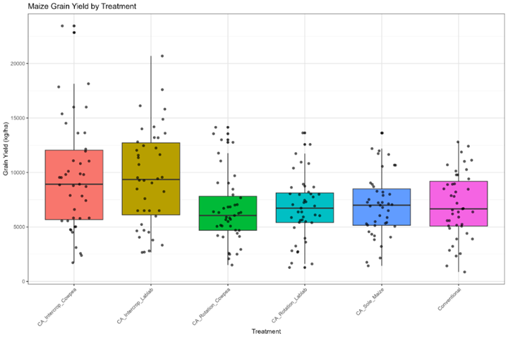

Chapter 3. Farm level analysis. Fitting or assessing SI options for maize to the diversity of famring systems.
Here you describe the survey, the PCA-HC, the farm types.
Performance of different types of farm in term of multicriteria assessmnet. What indicators (Economic benefit, food security, N and C balances, Leaisure time or labour productivity, etc…)?
A central figure for this chapter can be something like the one below.

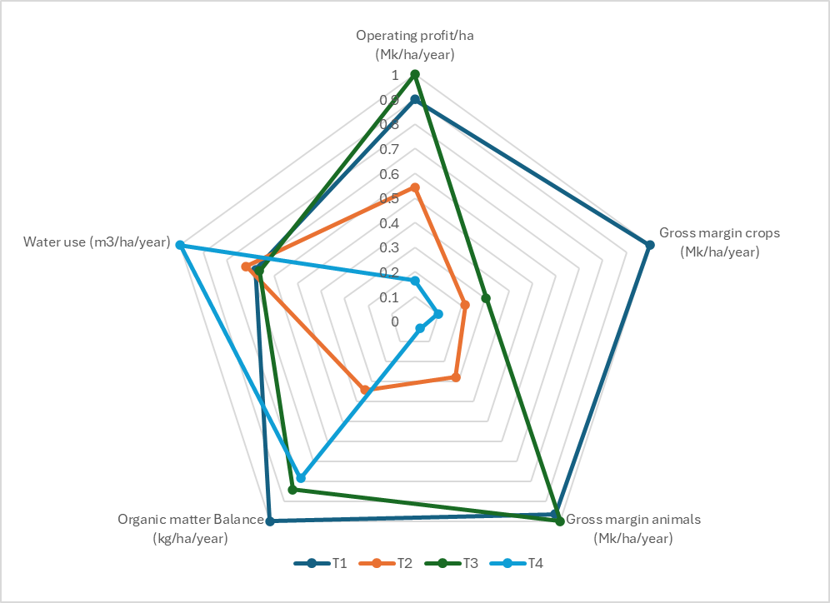

Chapter 4. Perception of farmers on the advantages, risk and farmer centered targeting of innovations.
I suggest to stat with the fact that, after the typology it can be seen the great diversity of livelihood strategies, including livestock, other crops, etc…So that in this chapter you will include the perception of farmers for a wider set of options for SI at the farm level.
Clearly define in a table the options:
Conservation Agriculture
Legume-Maize Rotation
Strip Cropping (Maize-Cowpea)
Small Livestock Integration
Fertilizer Micro-Dosing
Intercropping

Clearly define the criteria:
Productivity Potential;
Feasibility of Adoption;
Economic Viability,;
Resource Use Efficiency,
Scalability and Replicability,

You may want to show results of this type:
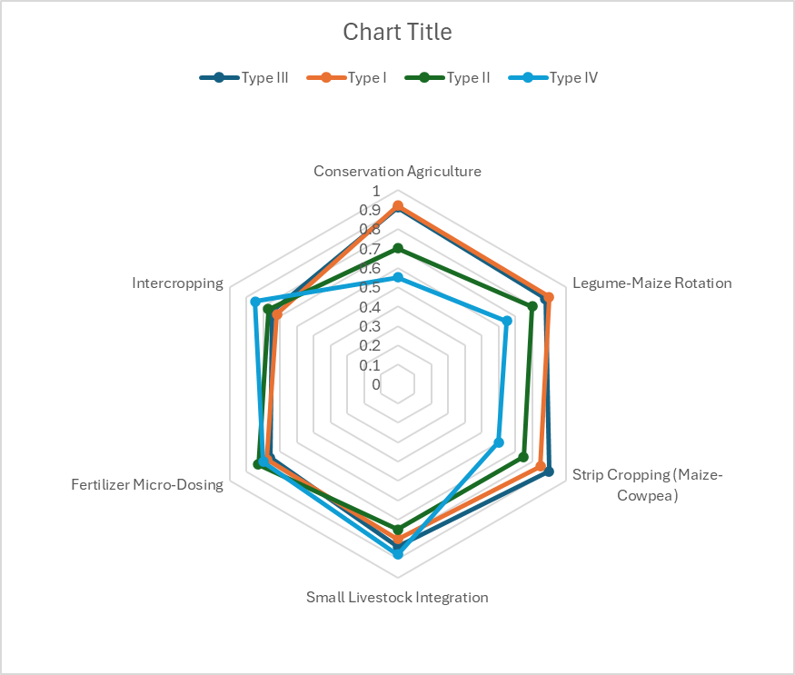

Chapter 5. If FarmDesign Explorations are ready and doable. Potential optimization of farms (from different types) through Farm Design including some of the SI innovations and see how trade offs are accentuated or smoothed, how windows of opportunities are expanded, etc…

Chapter 6 General Discussion and conclusions

